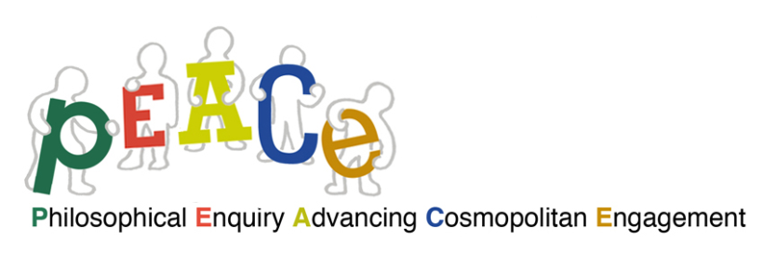

|  |  |  |  |  |  |  |
| --- | --- | --- | --- | --- | --- | --- |
| **Training courses already realized after the end of the project or scheduled to take place in the near future** | | | | | | |
| Topaz | On-line presentations of the PEACE materials trough the ICPIC website and network | 60 P4C practicioners expected | Raising awareness of a cosmopolitan frame of mind and introducing the PEACE curriculum to the ICPIC network | On line | February 2016 | Info : www.ICPIC.org |
| DSU | P4C sessions, based on the PEACE materials suitable for middle and high school students, were held on in the laboratory of Didactics and Special Pedagogy | 4 hours workshop | with post-degree students attending a Federico II university course named TFA, that provides participants with the qualification as a school teacher. | University of Naples Federico II, Italy | November 13th  2015 | Info: [info@p4c.unina.it](mailto:info@p4c.unina.it) |
| DSU | Training course in P4C with a special focus on the PEACE curriculum | 12 meetings lasting 4 hours each | Improving the teachers’ attitude and skills as P4C facilitators with the PEACE curriculum | University of Naples Federico II, Italy | November 2015-April 2016 | Info: <http://www.p4c.unina.it/index.html> |
| DSU | Training course - The PEACE curriculum promoting cosmopolitan attitude and inclusion | 12 meetings lasting 2 hours each | Improving the high school students‘ cosmopolitan attitude and skills by using the PEACE curriculum | Casanova high school in Naples, Italy | February -March 2016 | Info: [info@p4c.unina.it](mailto:info@p4c.unina.it) |
| DSU | MOOC concerning the PEACE curriculum on the platform of the European Multiple MOOC Aggregator (EMMA) |  | Free, open, online course about PEACE in multiple languages provided on the EU EMMA platform |  | It will be launched in March 2016 | <http://platform.europeanmoocs.eu/> |
| CFN-Garua | A series of workshops focused on PEACE education and values for 1st and 3rd ESO and Citizenship Education in 2nd ESO and tutoring | 90 teachers  expected | Raising awareness of the project and a cosmopolitan frame of mind and introducing the PEACE curriculum | Alberto Aldecoa” High School.  Madrid  (Spain) | 2015-2016 academic year | Info: http://filosofiaparaninos.org/ |
| CFN-Garua | Training course for high school teachers aiming at providing them comepetnces and skills to use the PEACE curriculum | 10 teachers expected | Working group of teachers from High School „Alberto Aldecoa“ to work with the curriculum and methodology of PEACE | Alberto Aldecoa” High School.  Madrid  (España) | 2015-2016 academic year | Info: http://filosofiaparaninos.org/ |
| CFN-Garua | Workshops with the PEACE materials for university students | 35 futures teachers and social educators expected | 2º Year of the Transversal subject in the curricula of Humanities, Education and other grades of the University of Alcalá | Facultad de EducaciónUniversidad de Alcalá  Alcalá de Henares Spain | From March to June 2016 | Info: http://filosofiaparaninos.org/ |
| CFN-Garua | Workshops with the PEACE materials for university students | 100 futures teachers and social educators expected | Teacher training in collaboration with the FUHEM | Madrid  (Spain) | 2015-2016 academic year | Info: http://filosofiaparaninos.org/ |
| OGK | A 3 days workshop organized during the Post Conference “Philosophy for Children”” | 20 philosophers, educators, teachers, teacher-trainers, students participated | Raising awareness of the project and a cosmopolitan frame of mind and introducing the PEACE curriculum. | Graz, Austria | October 18-20, 2015 | Info: http://www.kinderphilosophie.at/ |
| OGK | Training course - The PEACE curriculum promoting cosmopolitan attitude and inclusion | 45 high school students enrolled | 12 hours work-shops  improving the students‘ cosmopolitan attitude and skills by using the PEACE curriculum | Graz, Austria | November 2015-March 2016 | Info: http://www.kinderphilosophie.at/ |
| OGK | Presentation of the PEACE results to the North American Association for Community of Inquiry at Montclair State University |  | Raising awareness of the project and a cosmopolitan frame of mind and introducing the PEACE curriculum. | New Jersey, USA | June 17-20  2016 | 150 Philosophers, educators, teacher-trainers, teachers, students expected |
| OGK | Training course - The PEACE curriculum promoting cosmopolitan attitude and inclusion | 30 teachers and educators expected | Workshop – 5 days - raising awareness of the project and a cosmopolitan frame of mind and introducing the PEACE curriculum, improving skills by using the PEACE curriculum | Graz, Austria | July  2016 | Info: http://www.kinderphilosophie.at/ |